DR. THOMAS S. HOFFMAN, DO, MBA, FAsMA, USAF (ret)

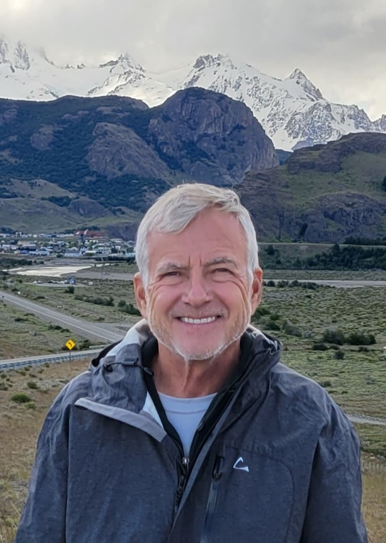
Dr. Hoffman, a US Naval Academy graduate, started his aviation career as a Naval Flight Officer flying EP-3s. He left the Navy to attend medical school and served in the US Air Force as a Flight Surgeon. He served with the DoD Human Space Flight Command as the DoD Surgeon, providing contingency support to NASA, including Return to Flight operations after the Columbia mishap. He was the 2005 Space Command Flight Surgeon of the Year.

After retirement from the Air Force, he served as a NASA Flight Surgeon at KSC, JSC, and in Star City, Russia.

After the conclusion of the Space Shuttle program, he left NASA and worked several different medical positions, including one “Summer” in Antarctica.

He then returned to civil service as the Medical Director “Surgeon” for the Defense POW/MIA Accounting Agency at Hickam AFB, HI, where he provided medical guidance for the Agency and recovery teams deployed around the world searching for missing personnel from past conflicts back to WW2.

Dr. Hoffman left DPAA after eight years to return to Florida to spend more time with family, particularly his grandsons. He currently works part time for Acuity International, a government and enterprise organizations contractor that provides health care, construction, humanitarian assistance, disaster response, and security services globally.

